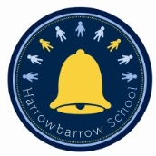
Harrowbarrow School PSA News
12th October 2017
Dear Parent/Carer
I would like to take this opportunity to introduce you all to the newest committee members of the PSA, provide you with some useful information as to what we do and to inform you of upcoming meetings and events.
The PSA is a team of committee members and volunteers whose aim it is to help raise additional funds for the school which benefit the children. We are able to provide these funds through the many fundraising events we hold during the school year i.e. the bake sales, raffles, school disco’s, Christmas crafts, sports days and more.
Now we have filled the committee positions we are looking for volunteers to provide ideas for events and/or people to help set up and contribute to the many events we hold. All parents, grandparents, uncles/aunties/brothers/sisters are welcome to volunteer.
I would like to introduce you to the current PSA Committee:
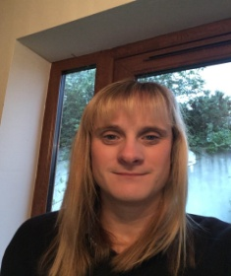 Michelle O’Neill – Chair Person
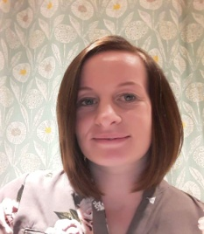 Leanne Wickett – Vice Chair Person
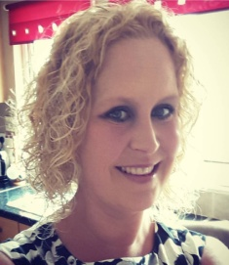 Liz Palmer - Treasurer
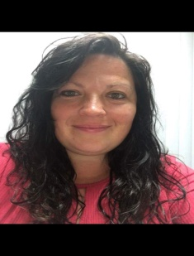 Claire Todd – Secretary
Upcoming PSA Meetings:
- Thursday 19th October 2017 (7pm) at the Carpenters Arms (our aim will be to plan the Christmas festivities)
- Thursday 11th January 2018 (7pm) at the Carpenters Arms (our aim will be to plan for Easter)
- Thursday 19th April 2018 (7pm) at the Carpenters Arms (our aim will be to plan for sports days)
All parents/carers/mums/dads/grandparents/uncles/aunties are welcome to join us at our meetings, either to provide ideas, volunteer or a way of getting to know other parents within the school.
Upcoming Events – dates for your diaries
- Christmas disco at Honicombe Manor on Wednesday 20th December 2017 15:30 – 17:30 £2.50 per child and £4.00 for 2 siblings (last day of school term).
- Christmas hamper, raffle, Christmas crafts, cake and more available during the infants and Juniors Christmas nativity plays and celebrations.
  - Infants Nativity Wednesday 6th December 2017 and Friday 8th December 2017
  - Juniors Christmas Celebration Tuesday 13th December 2017 and Wednesday 14th December 2017
On behalf of the PSA I would like to thank all of you for your continued support, we wouldn’t be able to raise as much money as we do for the school without it.
Finally I would like to give a massive thank you to Judith Caboche, Carla Moorcroft and Erin Beale for all of their hard work and dedication to the PSA over the past and previous years, the PSA would not have been able to continue without your support.
Yours sincerely

Michelle O’Neill
Chairperson

