Harrowbarrow School
Calculation Policy

November 2014

About Our calculation Policy

The following calculation policy has been devised to meet requirements of the National Curriculum 2014 for the teaching and learning of mathematics, and is also designed to give pupils a consistent and smooth progression of learning in calculations across the school. Please note that early learning in number and calculation in Reception follows the Development Matters‟ EYFS document, and this calculation policy is designed to build on progressively from the content and methods established in the Early Years Foundation Stage.

Age stage expectations:

The calculation policy is organised according to age stage expectations as set out in the National Curriculum 2014, however it is vital that pupils are taught according to the stage that they are currently working at, being moved onto the next level as soon as they are ready, or working at a lower stage until they are secure enough to move on.

Providing a context for calculation:

It is important that any type of calculation is given a real life context or problem solving approach to help build children's understanding of the purpose of calculation, and to help them recognise when to use certain operations and methods when faced with problems. This must be a priority within calculation lessons.

Choosing a calculation method:

Children need to be taught and encouraged to use the following processes in deciding what approach they will take to a calculation, to ensure they select the most appropriate method for the numbers involved:
To work out a tricky question wuestcalculation:
Approximate,
Calculate,
Check it mate!

Can I do it in my head using a

mental strategy?

Could I use some jottings to

help me?

Should I use a written method to work it out?

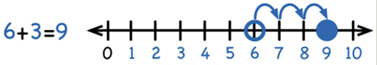

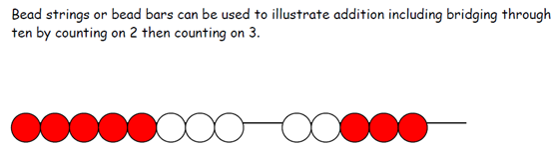

Stage 1 Add with numbers up to 20

Use numbered number lines to add, by counting on in ones. Encourage children to start with the larger number and count on.
+1 +1 +1

Children should:

• Have access to a wide range of counting equipment (Numicon, counters, bead strings etc), everyday objects, number tracks and number lines, and be shown numbers in different contexts.

• Read and write the addition (+) and equals (=) signs within number sentences.

• Interpret addition number sentences and solve missing box problems, using concrete objects and number line addition to solve them: 8 + 3 = 
15 + 4 =  5 + 3 + 1 =   +  = 6

This builds on from prior learning of adding by combining two sets of objects into one group (5 cubes and 3 cubes) in Early Years.

8 + 5

Key vocabulary: add, more, plus, and, make, altogether, total, equal to, equals, double, most,
count on, number line

Key skills for addition at Y1:

• Read and write numbers to 100 in numerals, incl. 1—20 in words
• Recall bonds to 10 and 20, and addition facts within 20
• Count to and across 100
• Count in multiples of 1 2, 5 and 10
• Solve simple 1-step problems involving addition, using objects, number lines and pictorial representations.

Video clips: Using a range of equipment and strategies to reinforce addition statements / bonds to 10

Stage 2 Add with 2-digit numbers Developing mental fluency with

addition and place value involving 2-digit numbers, then establish more formal methods.

Add 2-digit numbers and tens:
Add 2-digit numbers and units:
Use empty number lines, concrete equipment, hundred squares etc. to build confidence and fluency in
mental addition skills.

Add pairs of 2-digit numbers, moving to the partitioned column method when

secure adding tens and units:

23 + 34:

STEP 1:Only provide examples that do NOT cross the tens boundary until they are secure with the
method itself.

STEP 2: Once children can add a multiple of ten to a 2-digit
number mentally (e.g. 80+11), they are ready for adding pairs of
2-digit numbers that DO cross
the tens boundary (e.g. 58 + 43).
58 + 43:

STEP 3: Children who are confident and accurate with this stage should move onto the expanded addition methods with 2 and 3-digit
numbers (see Y3).

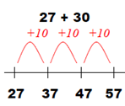

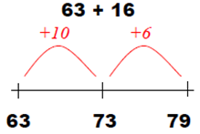

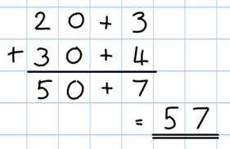

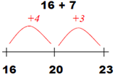

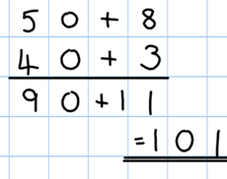

To support understanding, pupils may physically make and carry out the calculation with
Dienes Base 10 apparatus or place value counters, then compare their practical version to the written form, to help them to build an understanding of it.

Key vocabulary: add, more, plus, and, make, altogether, total, equal to, equals, double, most,
count on, number line, sum, tens, units, partition, addition, column, tens boundary

Key skills for addition at Y2:
• Add a 2-digit number and ones (e.g. 27 + 6)
• Add a 2-digit number and tens (e.g. 23 + 40)
• Add pairs of 2-digit numbers (e.g. 35 + 47)
• Add three single-digit numbers (e.g. 5 + 9 + 7)
• Show that adding can be done in any order (the commutative law).
• Recall bonds to 20 and bonds of tens to 100 (30 + 70 etc.)
• Count in steps of 2, 3 and 5 and count in tens from any number.
• Understand the place value of 2-digit numbers (tens and ones)
• Compare and order numbers to 100 using < > and = signs.
• Read and write numbers to at least 100 in numerals and words.
• Solve problems with addition, using concrete objects, pictorial representations, involving numbers,
quantities and measures, and applying mental and written methods.

Stage 3 Add numbers with up to 3-digits

Introduce the expanded column addition method:

Add the units first, in preparation for the compact method.

In order to carry out this method of addition:

• Children need to recognise the value of the hundreds, tens and units without recording the partitioning.

• Pupils need to be able to add in columns.

Move to the compact column addition method, with „carrying‟:

Add units first.

„Carry‟ numbers underneath the bottom line.
236

+ 73

309
1
Children who are very secure and confident with 3-digit
expanded column addition should be moved onto the compact column addition method, being introduced to „carrying‟ for the first time. Compare the expanded method to the
compact column method to develop an understanding of the
process and the reduced number of steps involved.

Remind pupils the actual value is „three tens add seven
tens‘, not ‗three add seven‟, which equals ten tens.

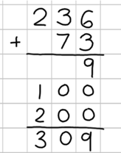

Key vocabulary: add, more, plus, and, make, altogether, total, equal to, equals, double, most, count on, number line, sum, tens, units, partition, plus, addition, column, tens boundary, hundreds boundary,
increase, vertical, ‗carry‘, expanded, compact

Key skills for addition at Y3:
• Read and write numbers to 1000 in numerals and words.
• Add 2-digit numbers mentally, incl. those exceeding 100.
• Add a three-digit number and ones mentally (175 + 8)
• Add a three-digit number and tens mentally (249 + 50)
• Add a three-digit number and hundreds mentally (381 + 400)
• Estimate answers to calculations, using inverse to check answers.
• Solve problems, including missing number problems, using
• number facts, place value, and more complex addition.
• Recognise place value of each digit in 3-digit numbers (hundreds, tens, ones.)
• Continue to practise a wide range of mental addition strategies, ie. number bonds, adding the nearest
multiple of 10, 100, 100 and adjusting, using near doubles, partitioning and recombining.
Video clip: D em on st rati on of exp an ded 3 -d igit co lu mn ad d iti o n

Stage 4 Add numbers with up to 4 digits

Move from expanded addition to the compact column method, adding units
first, and “carrying” numbers underneath the calculation. Also include money and measures contexts.

e.g. 3517 + 396 = 3913

Introduce the compact column addition method by asking children to add the two given numbers to- gether using the method that they are familiar
with (expanded column addition—see Y3). Teacher models the compact method with carrying, asking children to discuss similarities and differences and
establish how it is carried out.

Add units first.

“Carry”numbers underneath the bottom line.

Reinforce correct place value by reminding them the actual value is 5 hundreds add 3 hun- dreds, not 5 add 3, for example.

Use and apply this method to money and measurement values.

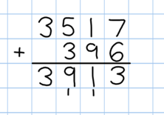

Key vocabulary: add, more, plus, and, make, altogether, total, equal to, equals, double, most, count on, number line, sum, tens, units, partition, plus, addition, column, tens boundary, hundreds boundary, increase, vertical, “carry”, expanded, compact, thousands, hundreds, digits, inverse

Key skills for addition at Y4:
• Select most appropriate method: mental, jottings or written and explain why.
• Recognise the place value of each digit in a four-digit number.
• Round any number to the nearest 10, 100 or 1000.
• Estimate and use inverse operations to check answers.
• Solve 2-step problems in context, deciding which operations and methods to use and why.
• Find 1000 more or less than a given number.
• Continue to practise a wide range of mental addition strategies, ie. number bonds, add the nearest multiple of 10, 100, 1000 and adjust, use near doubles, partitioning and recombining.
• Add numbers with up to 4 digits using the formal written method of column addition
• Solve 2-step problems in contexts, deciding which operations and methods to use and why.
• Estimate and use inverse operations to check answers to a calculation.

Stage 5 Add numbers with more than 4 digits

including money, measures and decimals with different numbers of decimal places.

The decimal point should be aligned in the same
way as the other place value columns, and must be in the same column in the answer.

Numbers should exceed 4 digits.

Pupils should be able to add more than two values, carefully aligning place value columns.

Say „6 tenths add 7 tenths‟
to reinforce place value.
Empty decimal places can be
filled with zero to show the place value in each column.

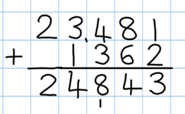

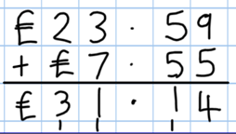

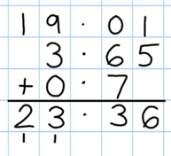

Children should:

• Understand the place value of tenths and hundredths and use this to align numbers with different numbers of decimal places.

Key vocabulary: add, more, plus, and, make, altogether, total, equal to, equals, double, most, count on, number line, sum, tens, units, partition, plus, addition, column, tens boundary, hundreds boundary, increase, „carry‟, expanded, compact, vertical, thousands, hundreds, digits, inverse & decimal places, decimal point, tenths, hundredths, thousandths

Key skills for addition at Y5:
• Add numbers mentally with increasingly large numbers, using and practising a range of mental strategies ie. add the nearest multiple of 10, 100, 100 and adjust; use near doubles, inverse, partitioning and
re-combining; using number bonds.
• Use rounding to check answers and accuracy.
• Solve multi-step problems in contexts, deciding which operations and methods to use and why.
• Read, write, order and compare numbers to at least 1 million and determine the value of each digit.
• Round any number up to 1 000 000 to the nearest 10, 100, 1000, 10 000 and 100 000.
• Add numbers with more than 4 digits using formal written method of columnar addition.

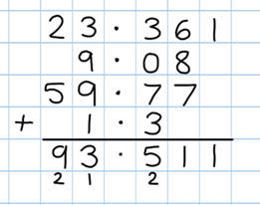

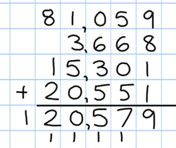

Stage 6 Add several numbers of increasing complexity

Adding several numbers with different numbers of decimal places (including money and measures):

• Tenths, hundredths and thousandths should be correctly aligned, with the decimal point lined up vertically including in the answer row.

• Zeros could be added into any empty decimal places, to show there is no value to add.

Empty decimal places can be filled with zero to show the place value in each column.

Adding several numbers with more than 4 digits.

Key vocabulary: add, more, plus, and, make, altogether, total, equal to, equals, double, most, count on, number line, sum, tens, units, partition, plus, addition, column, tens boundary, hundreds boundary,
increase, „carry‟, expanded, compact, vertical, thousands, hundreds, digits, inverse, decimal places, decimal point, tenths, hundredths, thousandths

Key skills for addition at Y6:
• Perform mental calculations, including with mixed operations and large numbers, using and practising a range of mental strategies.
• Solve multi-step problems in context, deciding which operations and methods to use and why.
• Use estimation to check answers to calculations and determine, in the context of a problem, levels of accuracy.
• Read, write, order and compare numbers up to 10 million and determine the value of each digit.
• Round any whole number to a required degree of accuracy.
• Pupils understand how to add mentally with larger numbers and calculations of increasing complexity.

Stage 1 Subtract from numbers up to 20

Children consolidate understanding of subtraction practically,
showing subtraction on bead strings, using cubes etc. and in familiar contexts, and are introduced to more formal recording using number lines as below:

Subtract by taking away

Read, write and interpret number sentences with
- and = signs.

Count back in ones on a numbered number line to take away, with numbers up to 20:

Find the “distance between‟
-1 -1 -1 -1

Model subtraction using hundred squares and numbered number lines/tracks and practically.

This will be introduced
practically with the language ‘find the distance between‘ and
‘how many more?' in a
range of familiar contexts.

“Seven is 3 more than four‟

“I am 2 years older than my sister‟

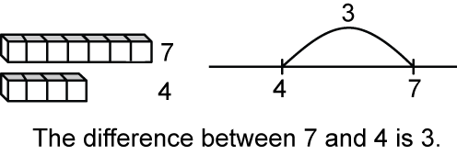

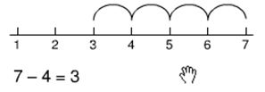

Mental subtraction

Children should start recalling subtraction facts up to and within 10 and 20, and should be able to subtract zero.

Key vocabulary: equal to, take, take away, less, minus, subtract, leaves, distance between, how
many more, how many fewer / less than, most, least, count back , how many left, how much less is_?

Key skills for subtraction at Y1:
• Given a number, say one more or one less.
• Count to and over 100, forward and back, from any number.
• Represent and use subtraction facts to 20 and within 20.
• Subtract with one-digit and two-digit numbers to 20, including zero.
• Solve one-step problems that involve addition and subtraction, using concrete objects (ie bead string, objects, cubes) and pictures, and missing number problems.
• Read and write numbers from 0 to 20 in numerals and words.

Stage 2 Subtract with 2-digit numbers

Subtract on a number line by counting back, aiming to develop
mental subtraction skills.

This strategy will be used for:
Use Dienes blocks for subtraction calculations too.

• 2-digit numbers subtract units (by taking away / counting back) e.g. 36—7
• 2-digit numbers subtract tens (by taking away / counting back) e.g. 48—30
• Subtracting pairs of 2-digit numbers (see below:)

Subtracting pairs of 2-digit numbers on a number line:

47 - 23 = 24 Partition the second number and subtract it in tens and units, as below:

Move towards more efficient jumps back, as below:

Then subtract units.
Subtract tens first.

Combine methods with use of a hundred square to reinforce understanding of
number value and order.

Teaching children to bridge through ten
can help them to become more efficient, for example 42—25:

Mental strategy - subtract numbers close together by counting on:

Start with the smaller number and count on to
the largest.

Many mental strategies are taught. Children are taught to recognise that when numbers are close together, it is more efficient to count on the difference. They need to be clear about the relationship between addition and subtraction.

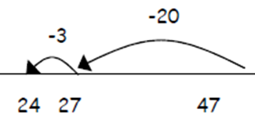

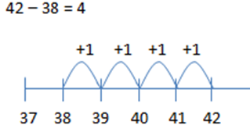

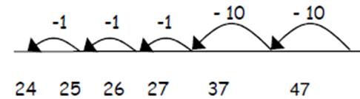

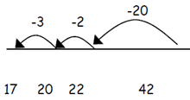

Key vocabulary: equal to, take, take away, less, minus, subtract, leaves, distance between, how
many more, how many fewer / less than, most, least, count back , how many left, how much less is_?
difference, count on, strategy, partition, tens, units
Key skills for subtraction at Y2:
• Recognise the place value of each digit in a two-digit number.
• Recall and use subtraction facts to 20 fluently, and derive and use related facts up to 100.
• Subtract using concrete objects, pictorial representations, 100 squares and mentally, including: a two- digit number and ones, a two-digit number and tens, and two two-digit numbers.
• Show that subtraction of one number from another cannot be done in any order.
• Recognise and use inverse relationship between addition and subtraction, using this to check calcula- tions and missing number problems.
• Solve simple addition and subtraction problems including measures, using concrete objects, pictorial
representation, and also applying their increasing knowledge of mental and written methods.
• Read and write numbers to at least 100 in numerals and in words.
Stage 3 Subtracting with 2 and 3-digit numbers.
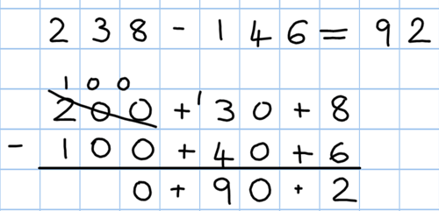

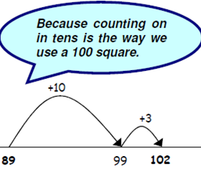

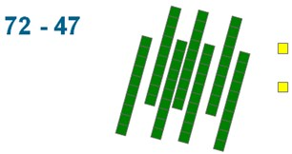

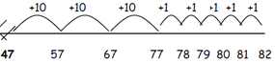

Introduce partitioned column subtraction method.

STEP 1: introduce this method with examples where no exchanging is required.

89 – 35 = 54

80 + 9
- 30 + 5
50 + 4
When learning to „exchange‟, explore
„partitioning in different ways‟ so that pupils understand that when you exchange, the VALUE is the same ie 72 = 70+2 = 60+12 = 50+22 etc. Emphasise that the value hasn‘t changed, we have just partitioned it in a different way.

STEP 2: introduce
„exchanging‟ through practical subtraction. Make the larger number with Base
10, then subtract 47 from
it.
70 + 2
- 40 + 7
20 + 5 = 25
Before subtracting ‘7’ from the 72 blocks, they will need to exchange a row of 10 for ten units. Then subtract 7, and subtract 4 tens.

STEP 3: Once pupils are secure with the understanding of
‟exchanging‟, they can use the
partitioned column method to subtract any 2 and 3-digit numbers.

Subtracting money:
partition into e.g.
£1 + 30p + 8p

Counting on as a mental strategy for subtraction:

Continue to reinforce counting on as a strategy for close-together numbers (e.g. 121—118), and also for numbers that are ‟nearly‟ multiples of 10, 100, 1000 or £s, which make it easier to count on (e.g. 102-89, 131—79, or calculating change from £1 etc.).
• Start at the smaller number and count on in tens first, then count on in units to find the rest of the difference:

Key vocabulary: equal to, take, take away, less, minus, subtract, leaves, distance between, how many more, how many fewer / less than, most, least, count back , how many left, how much less is_? difference, count on, strategy, partition, tens, units exchange, decrease, hundreds, value, digit
Key skills for subtraction at Y3:
• Subtract mentally a: 3-digit number and ones, 3-digit number and tens, 3-digit number and hundreds .
• Estimate answers and use inverse operations to check.

• Solve problems, including missing number problems.
• Find 10 or 100 more or less than a given number.
• Recognise the place value of each digit in a 3-digit number .
• Counting up differences as a mental strategy when numbers are close together or near multi-
ples of 10 (see examples above)
• Read and write numbers up to 1000 in numerals and words.
Approximate,

Calculate, Check it mate!

• Practise mental subtraction strategies, such as subtracting near multiples of 10 and adjusting (e.g. subtracting 19 or
21), and select most appropriate methods to subtract, explaining why.
Video clips: 1—Subtraction—teaching children to consider the most appropriate methods before calculating
2—Introducing partitioned column subtraction method, from practical to written

Stage 4 Subtract with up to 4-digit numbers

Partitioned column subtraction with „exchanging‟ (decomposition):

As introduced in Y3, but moving towards more complex numbers and values. Use place value coun-
ters to reinforce „exchanging‟.

Compact column subtraction (see video)
Subtracting money: partition
into £1 + 30 + 5 for example.

To introduce the compact method, ask children
to perform a subtraction calculation with the familiar partitioned column subtraction then display the compact version for the calculation
they have done. Ask pupils to consider how it relates to the method they know, what is similar and what is different, to develop an understanding of it (shown on video).

Give plenty of opportunities to apply this to money and measures.

Mental strategies
Always encourage children to consider the best method for the numbers involved— mental, counting on, counting back or writ- ten method (see video).

A variety of mental strategies must be taught and practised, including counting on to find
the difference where numbers are closer together, or where it is easier to

count on (see video below).
Approximate, Calculate,
Check it mate!

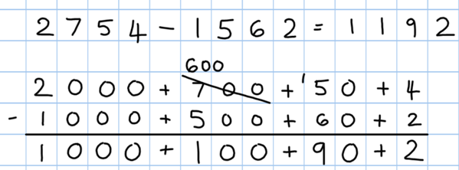

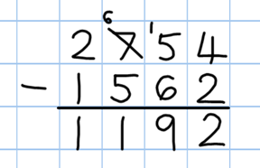

Key vocabulary: equal to, take, take away, less, minus, subtract, leaves, distance be-
tween, how many more, how many fewer / less than, most, least, count back , how many left, how much
less is_? difference, count on, strategy, partition, tens, units exchange, decrease, hundreds, value, digit,
inverse
Key skills for subtraction at Y4:
• Subtract by counting on where numbers are close together or they are near to multiples of 10, 100 etc.
• Children select the most appropriate and efficient methods for given subtraction calculations.
• Estimate and use inverse operations to check answers.
• Solve addition and subtraction 2-step problems, choosing which operations and methods to use and why.
• Solve simple measure and money problems involving fractions and decimals to two decimal places.
• Find 1000 more or less than a given number.
• Count backwards through zero, including negative numbers.
• Recognise place value of each digit in a 4-digit number Round any number to the nearest 10, 100 or 1000
• Solve number and practical problems that involve the above, with increasingly large positive numbers.
Videos: 1—Subtraction—teaching children to consider the most appropriate methods before calculating
2—Introducing partitioned column subtraction method, from practical to written
3—Moving to the compact column method of subtraction (youtube)

Stage 5 Subtract with at least 4-digit numbers

including money, measures, decimals.

Compact column subtraction

(with „exchanging‟).
Children who are still not secure with number facts and place value will need to remain on the partitioned column method until ready
for the compact method.

Subtracting with larger integers.

See ‗moving to
the compact
method‘ video.

Subtract with decimal values, including mixtures
of integers and decimals, aligning the decimal point.

Create lots of opportunities for subtracting and finding differences with money and measures.
Add a „zero‟ in any empty decimal places to aid understanding of what to subtract in that column.

Approximate,

Key vocabulary: equal to, take, take away, less, minus, subtract, leaves, distance between, how many more, how many fewer / less than, most, least, count back , how many left, how much less is_? difference, count on, strategy, partition, tens, units
Calculate, Check it mate!

exchange, decrease, hundreds, value, digit, inverse, tenths, hundredths, decimal point, decimal
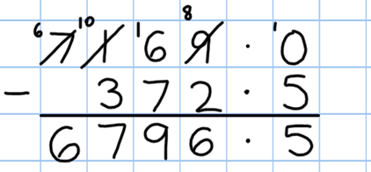

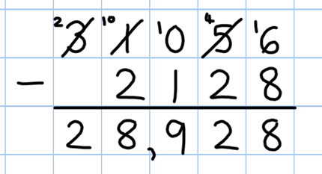

Key skills for subtraction at Y5:
• Subtract numbers mentally with increasingly large numbers .
• Use rounding and estimation to check answers to calculations and determine, in a range of contexts, levels of accuracy .
• Solve addition and subtraction multi-step problems in context, deciding which operations and methods
to use and why.
• Read, write, order and compare numbers to at least 1 million and determine the value of each digit.
• Count forwards or backwards in steps of powers of 10 for any given number up to 1 million.
• Interpret negative numbers in context, counting forwards and backwards with positive and negative in- tegers through 0.
• Round any number up to 1 million to the nearest 10, 100, 1000, 10 000 and 100 000.
Video clip:
Moving to the compact column method of subtraction (youtube)

Stage 6 Subtracting with increasingly large and more complex numbers and decimal values.

Using the compact column
method to subtract more complex integers

Using the compact column method to subtract money and measures, including decimals with different
numbers of decimal places.

Empty decimal places can be
filled with zero to show the place value in each column.

Pupils should be able to apply their knowledge of a range of mental strategies,
mental recall skills, and informal and formal written methods when selecting the most appropriate method to work out subtraction problems.

Approximate,

Key vocabulary: equal to, take, take away, less, minus, subtract, leaves, dis- tance between, how many more, how many fewer / less than, most, least, count
Calculate, Check it mate!

back , how many left, how much less is_? difference, count on, strategy, partition, tens, units exchange, decrease, hundreds, value, digit, inverse, tenths, hundredths, decimal point, decimal
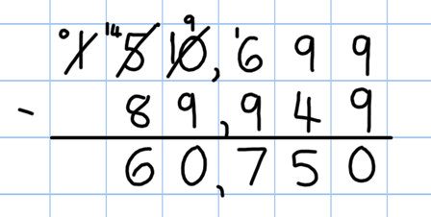

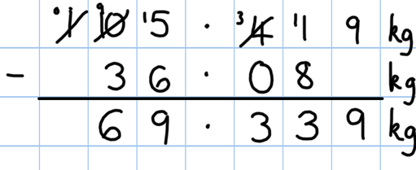

Key skills for subtraction at Y6:
• Solve addition and subtraction multi-step problems in context, deciding which operations and methods to use and why.
• Read, write, order and compare numbers up to 10 million and determine the value of each digit
• Round any whole number to a required degree of accuracy
• Use negative numbers in context, and calculate intervals
• across zero.
• Children need to utilise and consider a range of mental subtraction strategies, jottings and written methods before choosing how to calculate.

See previous videos for introducing the compact column method.

Stage 1 Multiply with concrete objects, arrays and

pictorial representations.

How many legs will 3 teddies have?
There are 3 sweets in one bag.
How many sweets are in 5 bags altogether?

2 + 2 + 2 = 6
3+3+3+3+3
= 15

• Give children experience of counting equal group of objects in 2s,
5s and 10s.

• Present practical problem solving activities involving counting equal sets or groups, as above.

Key vocabulary: groups of, lots of, times, array, altogether, multiply, count

Key skills for multiplication at Y1:

Count in multiples of 2, 5 and 10.
Solve one-step problems involving multiplication, by calculating the answer using concrete objects, pictorial representations and arrays with the support of the teacher.
Make connections between arrays, number patterns, and counting in twos, fives and tens. Begin to understand doubling using concrete objects and pictorial representations.

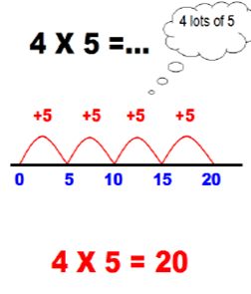

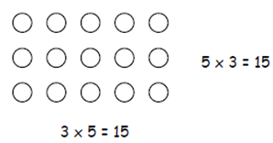

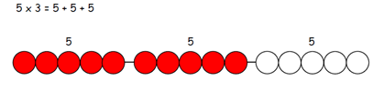

Stage 2 Multiply using arrays and repeated addition

(using at least 2s, 5s and 10s)

Use repeated addition on a number line:

• Starting from zero, make equal jumps up on
a number line to work out multiplication facts and write multiplication statements using x and = signs.

#

Use arrays:

5 x 3 = 3 + 3 + 3 + 3 = 15

3 x 5 = 5 + 5 + 5 = 15

Use arrays to help teach children to understand the commutative law of
multiplication, and give examples such as 3 x = 6.

Use practical apparatus:

Partitioning: Children to partition number given to complete multiplication
calculations involving 2s, 5s and 10s. E.g.12 x 4 = 10 x 4 = and 2 x 4 =

Key vocabulary: groups of, lots of, times, array, altogether, multiply, count, multiplied by, repeated addition, column, row, commutative, sets of, equal groups, times as big as, once, twice, three times...
Key skills for multiplication at Y2:
• Count in steps of 2, 3 and 5 from zero, and in 10s from any number.
• Recall and use multiplication facts from the 2, 5 and 10 multiplication tables, including recognising odds and evens.
• Write and calculate number statements using the x and = signs.
• Show that multiplication can be done in any order (commutative).
• Solve a range of problems involving multiplication, using concrete objects, arrays, repeated addition, mental methods, and multiplication facts.
• Pupils use a variety of language to discuss and describe multiplication.

Video clips:
Teaching for understanding of multiplication facts (youtube)
Practical multiplication and the commutative law (youtube)

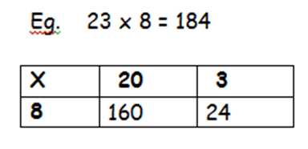

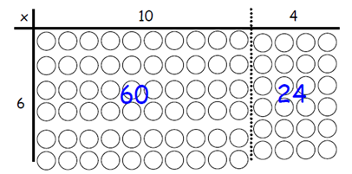

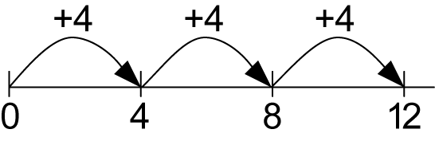

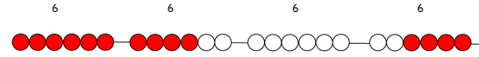

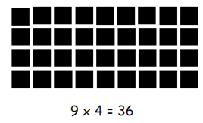

Stage 3 Multiply 2-digits by a single digit number

Introduce the grid method for multiplying 2-digit by single-digits:

Link the layout of the grid to an array initially:

160 + 24 = 184

Introduce the grid method with children physically making an array to represent the calculation (e.g. make 8 lots of 23 with 10s and 1s place value counters), then translate this to grid method format (see video clip).

To do this, children must be able to:

• Partition numbers into tens and units
• Multiply multiples of ten by a single digit (e.g. 20 x 4) using their knowledge of multiplication facts and place value
• Recall and work out multiplication facts in the 2, 3, 4, 5, 8 and 10 times tables.
• Work out multiplication facts not known by repeated addition or other taught mental strategies (e.g. by commutative law, working out near multiples and adjust- ing, using doubling etc.) Strategies to support this are repeated addition using a
number line, bead bars and arrays:

Key vocabulary: groups of, lots of, times, array, altogether, multiply, count, multiplied by, repeated ad- dition, column, row, commutative, sets of, equal groups, times, _times as big as, once, twice, three times...,
partition, grid method, multiple, product, tens, units, value
Key skills for multiplication:
• Recall and use multiplication facts for the 2, 3, 4, 5, 8 and 10 multiplication tables, and multiply multiples of 10.
• Write and calculate number statements using the multiplication tables they know, including 2-digit x single-digit, drawing upon mental methods, and progressing to reliable written methods.
• Solve multiplication problems, including missing number problems.
• Develop mental strategies using commutativity (e.g. 4 x 12 x 5 = 4 x 5 x 12 = 20 x 12 = 240)
• Solve simple problems in contexts, deciding which operations and methods to use.
• Develop efficient mental methods to solve a range of problems e.g using commutativity (4 × 12 × 5 =
4 × 5 × 12 = 20 × 12 = 240) and for missing number problems x 5 = 20, 3 x = 18, x = 32
Video clips: Teaching the grid method as an interim step (partitioning and counters to introduce grid)

Stage 4 Multiply 2 and 3-digits by a single digit, using

all multiplication tables up to 12 x 12

Developing the grid method:

500

150

+ 30

680

Encourage column addition to add accurately.

Move onto short multiplication (see Y5) if and when children are confident
and accurate multiplying 2 and 3-digit numbers by a single digit this way, and
are already confident in ‟carrying‟ for written addition.

Children should be able to:

• Approximate before they calculate, and make this a regular part of their calculating, going back to the approximation to check the reasonableness of their answer. e.g:

―346 x 9 is approximately 350 x 10 = 3500‖

Record an approximation to check the final answer against.

• Multiply multiples of ten and one hundred by a single-digit, using their multiplication table knowledge.

• Recall all times tables up to 12 x 12

Approximate, Calculate, Check it mate!

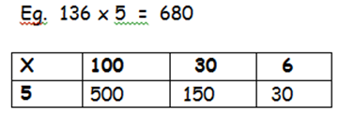

Key vocabulary: groups of, lots of, times, array, altogether, multiply, count, multiplied by, repeated addition, array, column, row, commutative, groups of, sets of, lots of, equal groups, times, multiply, times
as big as, once, twice, three times... partition, grid method, total, multiple, product, sets of, inverse
Key skills for multiplication at Y4:
• Count in multiples of 6, 7, 9, 25 and 1000
• Recall multiplication facts for all multiplication tables up to 12 x 12.
• Recognise place value of digits in up to 4-digit numbers
• Use place value, known facts and derived facts to multiply mentally, e.g. multiply by 1, 10, 100, by 0, or to multiply 3 numbers.
• Use commutativity and other strategies mentally 3 x 6 = 6 x 3 , 2 x 6 x 5 = 10 x 6 , 39x7 = 30 x 7 + 9 x 7.
• Solve problems with increasingly complex multiplication in a range of contexts.
• Count in multiples of 6, 7, 9, 25 and 1000
• Recognise the place value of each digit in a four-digit number (thousands, hundreds, tens, and ones)

Stage 5 Multiply up to 4-digits by 1 or 2 digits.

Introducing column multiplication

• Introduce by comparing a grid method calculation to a short multiplication meth- od, to see how the steps are related, but notice how there are less steps involved in the column method (see video).
• Children need to be taught to approximate first, e.g. for 72 x 38, they will use rounding: 72 x 38 is approximately 70 x 40 = 2800, and use the approximation to check the reasonableness of their answer against.

Short multiplication for multiplying by a single digit
Pupils could be asked to work out a given calculation using the grid, and then compare it to „your‟ column method. What are the similarities and differences? Unpick the steps
x | 300 | 20 | 7
4 | 1200 | 80 | 28

and show how it reduces the steps.

Introduce long multiplication for multiplying by 2 digits

18 x 3 on the 1st row

(8 x 3 = 24, carrying the 2
for twenty, then „1‟ x 3).

Moving towards more complex numbers:

18 x 10 on the 2nd row. Put a zero in units first, then say 8 x 1, and 1 x 1.

Approximate,

Calculate,

(1234 x 6)

(1234 x 10)
Check it mate!

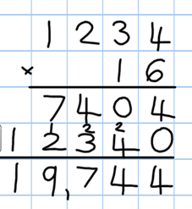

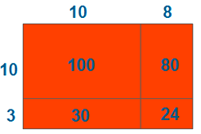

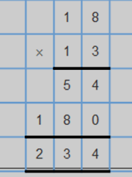

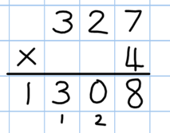

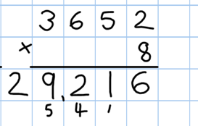

Key vocabulary groups of, lots of, times, array, altogether, multiply, count, multiplied by, repeated ad- dition, column, row, commutative, sets of, equal groups, _times as big as, once, twice, three times..., parti-
tion, grid method, total, multiple, product, inverse, square, factor, integer, decimal, short/long multi-
plication, ‗carry‘
Key skills for multiplication at Y5:
Identify multiples and factors, using knowledge of multiplication tables to 12x12.
Solve problems where larger numbers are decomposed into their factors
Multiply and divide integers and decimals by 10, 100 and 1000
Recognise and use square and cube numbers and their notation
Solve problems involving combinations of operations, choosing and using calculations and methods appropriately.
Video clips:
Moving from grid method to a compact method Reinforcing rapid times table recall:
Demonstration of long multiplication

Stage 6 Short and long multiplication as in Y5, and
multiply decimals with up to 2d.p by a single digit.

Line up the decimal points in the question
and the answer.

Remind children that the single digit belongs in the units column.

This works well for multiplying money (£.p) and
other measures.

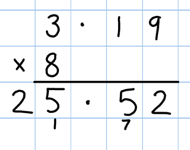

Children will be able to:

• Use rounding and place value to make approximations before calculating and use these to check answers against.

• Use short multiplication (see Y5) to multiply numbers with more than 4-digits by a single digit; to multiply money and measures, and to multiply decimals with up to 2d.p. by a single digit.

• Use long multiplication (see Y5) to multiply numbers with at least 4 digits by a
2-digit number.
Approximate,
Calculate, Check it mate!

Key vocabulary: groups of, lots of, times, array, altogether, multiply, count, multiplied by, repeated ad- dition, array, column, row, commutative, sets of, equal groups, times as big as, once, twice, three times...
partition, grid method, total, multiple, product, inverse, square, factor, integer, decimal, short / long mul-
tiplication, „carry‟, tenths, hundredths, decimal
Key skills for multiplication at Y6:
• Recall multiplication facts for all times tables up to 12 x 12 (as Y4 and Y5).
• Multiply multi-digit numbers, up to 4-digit x 2-digit using long multiplication.
• Perform mental calculations with mixed operations and large numbers.
• Solve multi-step problems in a range of contexts, choosing appropriate combinations of opera- tions and methods.
• Estimate answers using round and approximation and determine levels of accuracy.
• Round any integer to a required degree of accuracy.

Video clips:
Moving from grid method to a compact method (youtube) Reinforcing rapid times table recall: (youtube)
Demonstration of long multiplication (SLEP)

Stage 1 Group and share small quantities

Using objects, diagrams and pictorial representations to solve problems involv- ing both grouping and sharing.

How many groups of 4 can be made with 12 stars? = 3

Grouping:

Sharing:

Pupils should :
Example division problem
in a familiar context:

There are 6 pupils on this table and there are 18 pieces of fruit to share between us. If we share them equally, how many will we each get?

Can they work it out and give
a division statement… ?

“18 shared between 6 people gives you 3 each.”

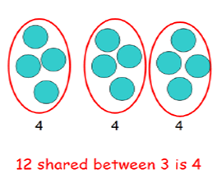

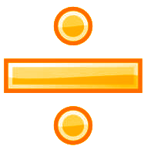

• use lots of practical apparatus, arrays and picture representations

• Be taught to understand the difference between „grouping‟ objects (How many groups of 2 can you make?) and „sharing‟ (Share these sweets between 2 people)
• Be able to count in multiples of 2s, 5s and 10s.

• Find half of a group of objects by sharing into 2 equal groups.

Key Vocabulary: share, share equally, one each, two each…, group, groups of, lots of, array

Key number skills needed for division at Y1:
• Solve one-step problems involving multiplication and division, by calculating the answer using concrete objects, pictorial representations arrays with the support of the teacher
• Through grouping and sharing small quantities, pupils begin to understand, division, and finding
simple fractions of objects, numbers and quantities.
• They make connections between arrays, number patterns, and counting in twos, fives and tens.

Stage 2 Group and share, using the ÷ and = sign

Use objects, arrays, diagrams and pictorial representations, and grouping on a number line.

Arrays:
This represents 12 ÷ 3, posed as
how many groups of 3 are in 12?

Pupils should also show that the same array can represent 12 ÷ 4 =
3 if grouped horizontally.

Know and understand sharing and grouping:

Grouping

Sharing

Children should be taught to recognise whether problems require sharing or grouping.

Grouping using a number line:
+3 +3 +3 +3

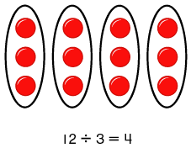

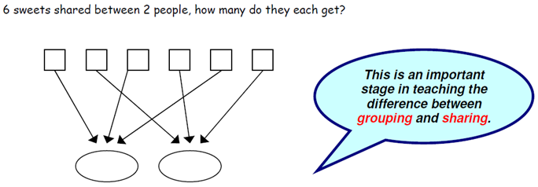

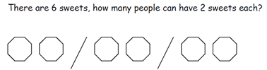

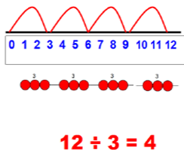

Group from zero in equal jumps of the divisor to find
out ‟how many groups of _ in _ ?‟. Pupils could and using a bead string or practical apparatus to work out problems like „A CD costs £3. How many CDs can I buy with £12?‟ This is an important method to
develop understanding of division as grouping.

Pose 12 ÷ 3 as „How many groups of 3 are in 12?‟

Key Vocabulary: share, share equally, one each, two each…, group, equal groups of, lots of,
array, divide, divided by, divided into, division, grouping, number line, left, left over
Key number skills needed for division at Y2:
• Count in steps of 2, 3, and 5 from 0
• Recall and use multiplication and division facts for the 2, 5 and 10 multiplication tables, including recognising odd and even numbers.
• Calculate mathematical statements for multiplication and division within the multiplication tables and write them using the x, ÷ and = signs.
• Show that multiplication of two numbers can be done in any order (commutative) and division of one
number by another cannot.
• Solve problems involving multiplication and division, using materials, arrays, repeated addition, mental methods, and multiplication and division facts, including problems in contexts.

Stage 3 Divide 2-digit numbers by a single digit

(where there is no remainder in the final answer)

Grouping on a number line:
 |  |  | 4 r 1 | now taught the concept of remainders, as in the example. This should be introduced practically and with arrays, as well as
+3 | +3 | +3 | +3 r 1 | being translated to a number line. Children should work
 |  |  |  | towards calculating some basic division facts with remainders
 |  |  |  | mentally for the 2s, 3s, 4s, 5s, 8s and 10s, ready for „carrying‟
 |  |  |  | remainders across within the short division method.

STEP 1: Children continue to work out unknown division
facts by grouping on a number line from zero. They are also

Real life contexts need to be used routinely to help pupils gain a full understand- ing, and the ability to recognise the place of division and how to apply it to problems.

Short division: Limit numbers to NO remainders in the answer OR carried (each digit must be a multiple of the divisor).

Short division: Limit numbers to NO remainders in the final answer, but with remainders occurring within the
STEP 2: Once children are secure with division as grouping and demonstrate this using number lines, arrays etc., short division for larger 2-digit numbers should be introduced, initially with carefully selected examples requiring no calculating of remainders at all. Start by introducing the layout of short division by comparing it to an array.

Remind children of correct place value, that 96 is equal to 90 and 6, but in short division, pose:
• How many 3‟s in 9? = 3, and record it above the 9 tens.

• How many 3‟s in 6? = 2, and record it above the 6 units.

STEP 3: Once children demonstrate a full understanding of remainders, and also the short division method taught, they can be taught how to use the method when remainders occur within the calculation (e.g. 96†4), and be taught to „carry‟ the
remainder onto the next digit. If needed, children should use the number line to work out individual division facts that
occur which they are not yet able to recall mentally.

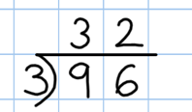

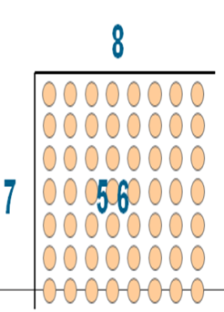

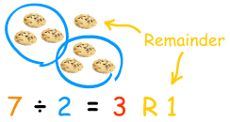

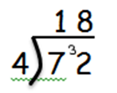

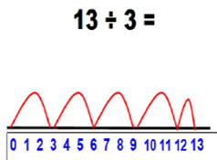

Step 3 Only taught when pupils can calculate „remainders‘.

Key Vocabulary: share, share equally, one each, two each…, group, equal groups of, lots of, array, divide, divided by, divided into, division, grouping, number line, left, left over, inverse, short division, ‗carry‘, remainder, multiple
Key number skills needed for division at Y3:
• Recall and use multiplication and division facts for the 2, 3, 4, 5, 8 and 10 multiplication tables (through dou-
bling, connect the 2, 4 and 8s).
• Write and calculate mathematical statements for multiplication and division using the multiplication tables that they know, including for two-digit numbers times one-digit numbers, using mental and progressing to for-
mal written methods.
• Solve problems, in contexts, and including missing number problems, involving multiplication and division.
• Pupils develop efficient mental methods, for example, using multiplication and division facts (e.g. using 3 × 2 =
6, 6 ÷ 3 = 2 and 2 = 6 ÷ 3) to derive related facts (30 × 2 = 60, so 60 ÷ 3 = 20 and 20 = 60 ÷ 3).
• Pupils develop reliable written methods for division, starting with calculations of 2-digit numbers by 1-digit numbers and progressing to the formal written method of short division.

Stage 4 Divide up to 3-digit numbers by a single digit

(without remainders initially)

Continue to develop short division:

Short division should only be taught once children have secured the skill of
calculating „remainders‟.

STEP 1: Pupils must be secure with the process of
short division for dividing 2-digit numbers by a single digit (those that do not result in a final remainder
—see steps in Y3), but must understand how to
calculate remainders, using this to „carry‟ remainders
within the calculation process (see example).

Real life contexts need to be used routinely to help pupils gain a full understand- ing, and the
ability to
STEP 2: Pupils move onto dividing numbers with up
to 3-digits by a single digit, however problems and calculations provided should not result in a final answer with remainder at this stage. Children
who exceed this expectation may progress to Y5
level.

When the answer for the first column is zero

recognise the place of division and how to apply it to
problems.
(1 ÷ 5, as in example), children could initially write a zero above to acknowledge its place, and must always „carry‟ the number (1) over to the next digit as a remainder.
Include money and measure contexts when confident.

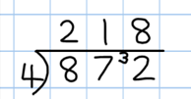

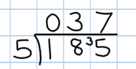

Key Vocabulary: share, share equally, one each, two each…, group, equal groups of, lots of, array, divide, divided by, divided into, division, grouping, number line, left, left over, inverse, short division, „carry‟,
remainder, multiple, divisible by, factor
Key number skills needed for division at Y4:
• Recall multiplication and division facts for all numbers up to 12 x 12.
• Use place value, known and derived facts to multiply and divide mentally, including: multiplying and dividing by 10 and 100 and 1.
• Pupils practise to become fluent in the formal written method of short division with exact answers when
dividing by a one-digit number
• Pupils practise mental methods and extend this to three-digit numbers to derive facts, for example 200
× 3 = 600 so 600 ÷ 3 = 200
• Pupils solve two-step problems in contexts, choosing the appropriate operation, working with increasingly harder numbers. This should include correspondence questions such as three cakes shared equally
between 10 children.

Stage 5 Divide up to 4 digits by a single digit, including

those with remainders.

Short division, including remainder answers:

The answer to 5309 ÷ 8 could be expressed as 663 and five eighths,
663 r 5, as a decimal, or rounded as appropriate to the problem involved.

Include money
Short division with remainders: Now that pupils are introduced to examples that give rise to remainder answers, division needs to have a real life problem solving context, where pupils consider the meaning of the remainder and how to express it, ie. as a fraction, a decimal, or as a rounded number or value , depending upon the context of the problem.

See Y6 for how to continue the short division to give a decimal answer for children who are confident.

Key Vocabulary: share, share equally, one each, two each…, group, equal groups of, lots of, array,
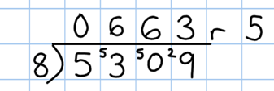

divide, divided by, divided into, division, grouping, number line, left, left over, inverse, short division,
„carry‟, remainder, multiple, divisible by, factor, inverse, quotient, prime number, prime factors, composite number (non-prime)
Key number skills needed for division at Y5:
• Identify multiples and factors, including finding all factor pairs of a number, and common factors of two number.
• Multiply and divide whole numbers and those involving decimals by 10, 100 and 1000.
• Use the vocabulary of prime numbers, prime factors and composite (non-prime) numbers.
• Work out whether a number up to 100 is prime, and recall prime numbers to 19.
• Divide numbers up to 4 digits by a one-digit number using the formal written method of short division and inter- pret remainders appropriately for the context
• Interpret non-integer answers to division by expressing results in different ways according to the context, includ- ing with remainders, as fractions, as decimals or by rounding (e.g. 98 ÷ 4 = 24 r 2 = 241/2 = 24.5 ≈ 25).

Stage 6 Divide at least 4 digits by both single-digit and
2-digit numbers (including decimal numbers and quantities)

Short division, for dividing by a single digit: e.g. 6497 ÷ 8

Short division with remainders: Pupils should continue to use this method, but with numbers to at least 4 digits, and understand how to express remainders as fractions, deci- mals, whole number remainders, or rounded numbers. Real life problem solving contexts need to be the starting point, where pupils have to consider the most appropriate way to express the remainder.
Calculating a decimal remainder: In this example, rather than expressing the remainder as r 1, a decimal point is added after the units because there is still a remainder, and the one remainder is carried onto zeros after the decimal point (to show there was no decimal value in the original number).
Keep dividing to an appropriate degree of accuracy for the problem being solved.

Must be
Continue long division by chunking for dividing by 2 digits.

• Find out „How many 36s are in 972?‟ by

aligned in place value for subtracting.
subtracting „chunks‟ of 36, until zero is
reached (or until there is a remainder).
• Teach pupils to write a „useful list‘ first at
the side that will help them decide what chunks to use, e.g.:
‗Useful‘ list: 1x = 36
10x = 360
100x = 3600
• Introduce the method in a simple way by
limiting the choice of chunks to „Can we use
10 lots? Can use 100 lots? As children become confident with the process, encourage more efficient chunks to get to the answer more quickly (e.g. 20x, 5x), and expand on their „useful‟ lists.
Where remainders
occur, pupils should express them as fractions, decimals or use rounding, depend- ing upon the problem.

Approximate, Calculate,
Check it mate!

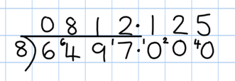

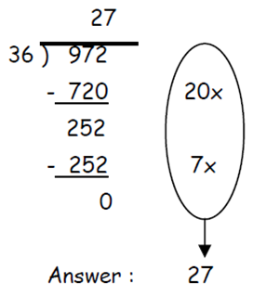

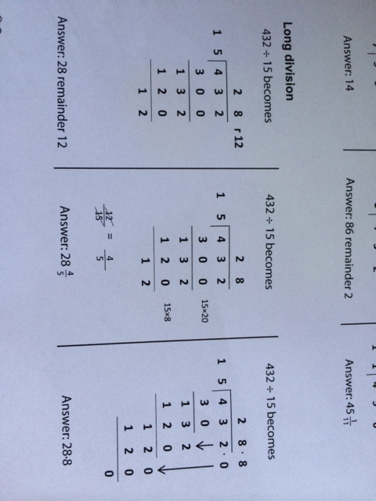
Children should progress through the following methods of recording in order to record remainders as fractions, decimals or by rounding depending upon the context of the calculation given by the problem.

Key Vocabulary: As previously, & common factor
Key number skills needed for division at Y6:
• Recall and use multiplication and division facts for all numbers to 12 x 12 for more complex calculations
• Divide numbers up to 4 digits by a two-digit whole number using the formal written method of long divi- sion, and interpret remainders as whole number remainders, fractions, or by rounding, as appropriate for
the context. Use short division where appropriate.
• Perform mental calculations, including with mixed operations and large numbers.
• Identify common factors, common multiples and prime numbers.
• Solve problems involving all 4 operations.
• Use estimation to check answers to calculations and determine accuracy, in the context of a problem.
• Use written division methods in cases where the answer has up to two decimal places.
• Solve problems which require answers to be rounded to specified degrees of accuracy.

