Tuesday 24th September
Dear parents/carers
Accelerated Reader
We have started using a new reading programme in school. The programme uses a Star Quiz to determine your child’s reading level. Pupils take a Star Quiz every half term. They are then given a ZPD which is basically their reading level. This is a range of books within their reading range. All the books in the library and from the classes have been assigned a reading level. Your child can choose from within this range. The lower the reading band, the easier it will be for them to read. The higher the reading band, the harder it will be to read.
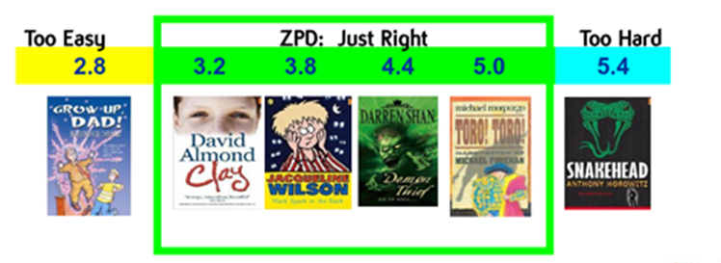
Pupils also now complete quizzes once they have read a book. This is to check their comprehension.
You are able to track how well your child is doing online. The attached letter gives more information about logging on. You will need to use the exact URL address. Pupils are not able to access Star Reading quizzes or book quizzes at home.
Please encourage your child to have their Accelerated Reader book in school as we are aiming to read every day. Also encourage them to read for at least 20 minutes each day at home as well. Pupils will change books during lesson time.
If you have any questions please feel free to see myself or Mr Watts.
Kind regards

Miss Pinfield

