Monday: I can add and subtract fractions with denominators that are multiples of the same number.
How to do this:

 | Problem | Step 1: Find a common denominator | Step 2: Add the numerators | Answer
 | $\frac{3}{4}$ + $\frac{2}{8}$ = | $\frac{3}{4}$ + $\frac{2}{8}$ =  becomes  $\frac{6}{8}$ + $\frac{2}{8}$ = | $\frac{6}{8}$ + $\frac{2}{8}$ = $\frac{8}{8}$ | $$\frac{8}{8}$$
Top tips | Numerator –  Denominator - | Both 4 and 8 are in the 4 times table, so you can multiply the 4 by 2 to give you the same denominators.  Remember: whatever you do to the denominator, you have to do to the numerator too. So, 3 x 2 x 6 | When the denominators are the same, you can add the fractions.  Remember: you only add the numerators. The denominators stay the same.

Challenge 1:
$\frac{2}{3}$ + $\frac{1}{3}$= $\frac{1}{4}$ + $\frac{3}{4}$= $\frac{1}{5}$ + $\frac{4}{5}$= $\frac{5}{6}$ + $\frac{1}{6}$=

What do you notice? Why should this be?

Challenge 2:
$\frac{2}{3}$ + $\frac{1}{6}$ = $\frac{3}{10}$ + $\frac{5}{20}$ = $\frac{1}{7}$ + $\frac{2}{14}$ = $\frac{3}{6}$ + $\frac{2}{12}$ =

How can you check your workings out? How can you prove that you are right?
If you got them right, try this:
A bag of Lego is made up of $\frac{1}{4}$ blue bricks and $\frac{2}{8}$ of red bricks. The rest are yellow bricks. What fraction are yellow bricks?
Now can you write your own word problem with fractions in different denominators?

Tuesday
I can add and subtract fractions with denominators that are multiples of the same number.
Challenge 1
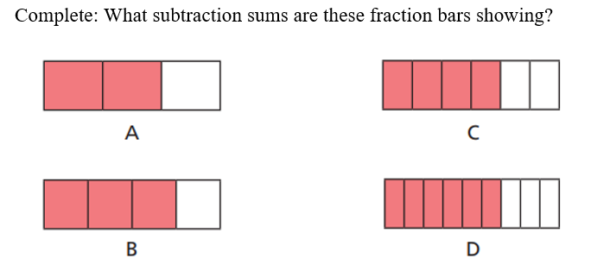
Challenge 2
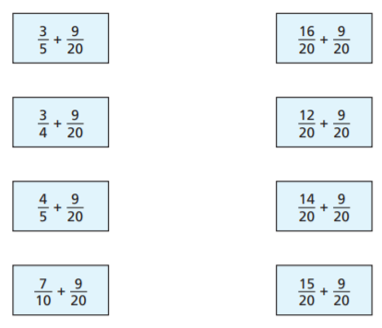
Challenge 3
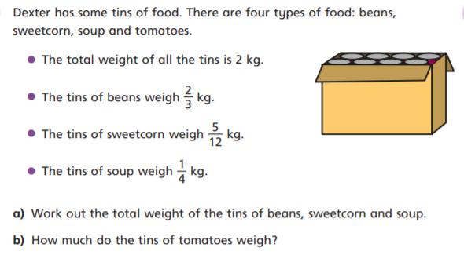

Wednesday
I can add and subtract fractions with denominators that are multiples of the same number.
Challenge 1

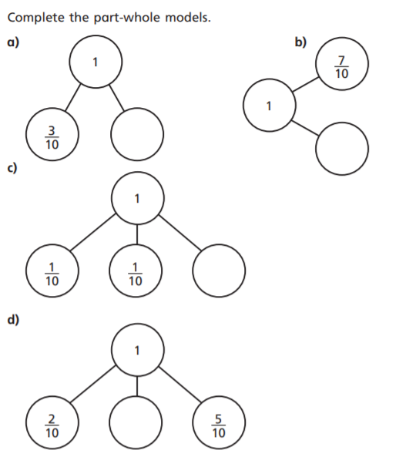
Challenge 2
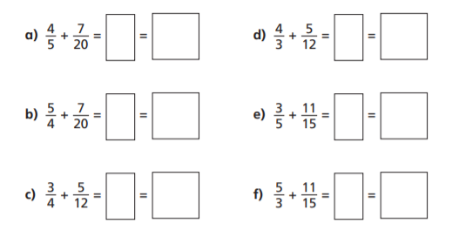
Challenge 3
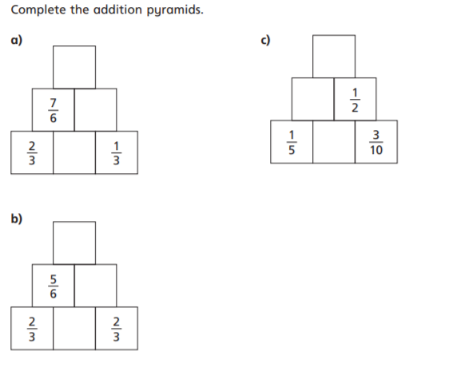

Thursday – times tables challenge
Play TT Rockstars or Hit the Button as a warm up game. Links can be found on the Class 4 webpage. Now try these:
Bronze  5x and 10x tables  - 3 x 5  - 4 x 5  - 10 x 5  - 8 x 5  - 9 x 5  - 10 x 10  - 5 x 10  - 8 x 10  - 9 x 10  - 11 x 10 | Silver  7 x tables  - 6 x 7  - 60 x 7  - 600 x 7  - 6,000 x 7  - 60 x 70  - 60 x 700  - 420 divided by 7  - 4,200 divided by 7  - 42,000 divided by 7  - 42,000 divided by 70 | Gold  7x tables with decimals  - 0.6 x 7  - 6 x 0.7  - 0.6 x 0.7  - 0.6 x 70  - 0.6 x 700  - 4.2 divided by 7  - 4.2 divided by 6  - 0.42 divided by 7  - 0.42 divided by 6  - 4.2 divided by 70

Friday
I can add and subtract fractions with denominators that are multiples of the same number.
Challenge 1
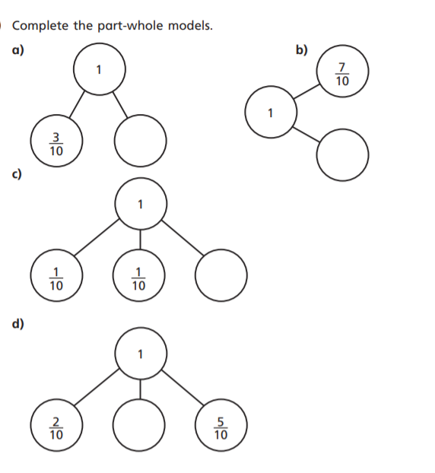
Challenge 2
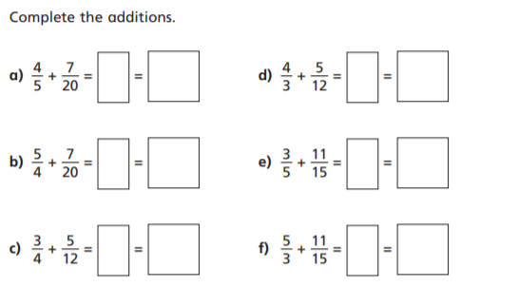

Challenge 3
