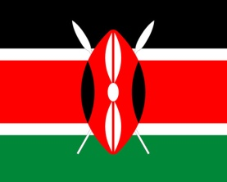  
  
Kenya

2 x 4

9 x 6

8 x 8

10 x 4

10 x 6

12 x 6

12 x 8

7 x 6

4 x 6

1 x 4

7 x 8

7 x 4

6 x 8

10 x 8

5 x 6

6 x 4

11 x 8

1 x 8

2 x 8

9 x 4

4 x 8

3 x 4

9 x 8

8 x 4

2 x 6

5 x 8

6 x 6

3 x 8

5 x 4

12 x 4

11 x 4

4 x 4

1 x 6

11 x 6

8 x 6

3 x 6

11 x 4

8 x 4

2 x 4

9 x 4

5 x 4

6 x 4

3 x 6

7 x 4

1 x 8

6 x 8

10 x 4

12 x 4

8 x 6

4 x 8

1 x 4

11 x 6

5 x 8

5 x 6

12 x 6

2 x 8

4 x 6

9 x 6

1 x 6

4 x 4

3 x 8

10 x 8

7 x 8

7 x 6

10 x 4

2 x 6

11 x 8

9 x 8

6 x 6

8 x 8

3 x 4

12 x 8

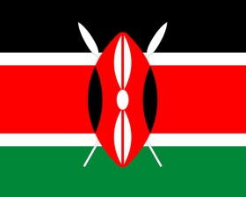

Kenya