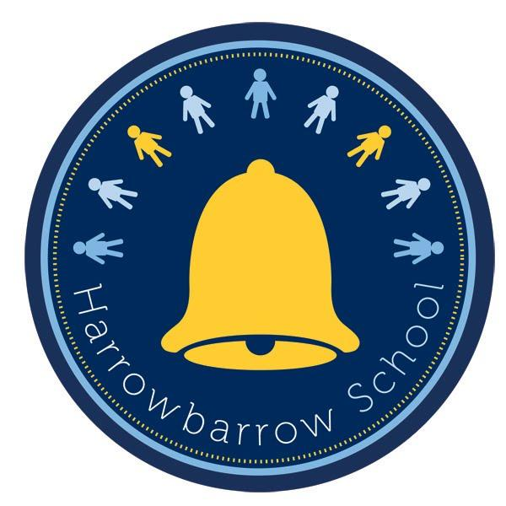
HARROWBARROW SCHOOL
PE Curriculum Intent

Intent

At Harrowbarrow School, we strongly believe that all children should have access to an engaging, safe and stimulating PE curriculum, which will help pupils deepen their understanding in a sequential way to motivate them to lead a healthy, active lifestyle. Our teachers strive to equip all children with the necessary skills, knowledge and range of physical experiences whilst encouraging healthy competition, teamwork and lifelong participation in physical activity and sport.
Implementation
PE at Harrowbarrow Primary School provides challenging and enjoyable learning through a range of sporting activities including invasion games, net and wall games, strike and field games, gymnastics, dance, swimming and outdoor and adventure.
- Teachers plan lessons and use age appropriate resources to ensure lessons across years show progression.
- The long term plan sets out the PE units which are to be taught throughout the year and ensures that the requirements of the National Curriculum are fully covered.
- Children participate in two high quality PE lessons each week, covering different PE areas every half term. In addition, children are encouraged to participate in a range of extra-curricular activities, after school and outside of school.
- Children are invited to attend competitive sporting events throughout the year and festivals within the local area, including those supported by Arena in the local area. This is an inclusive approach which endeavours to encourage not only physical development but also mental well-being. These events also develop teamwork and leadership skills and are very much enjoyed by the children across the school.
- All classes participate in daily activities to help children meet the 30 minutes of daily physical activity at school. Children are encouraged to participate in active lunch and break times by using the adventure trail, playground markings, table tennis tables, netball hoops and playground equipment.
- iMoves and Just Dance is used to encourage movement between different lessons during the day; this not only benefits their fitness but also their mental health.
- Each year, a group of Year 6 children are invited to become playground pals for the school. They develop into role models for the younger children, promoting active break times across the school and help to engage other children with different playground games and sports.
- Children may participate in workshops or events covering a variety of sports throughout the year. These provide the children with an opportunity to develop and improve their fitness and to try something new, these can be organised with local schools or through Arena.
- Children in Years 1 to 6 swim once a week for 6/7 weeks within the year.
- We provide children with opportunities to participate in extra-curricular activities that are inclusive, enjoyable and increase children’s physical activity.
Impact
As a result of Harrowbarrow’s PE curriculum and coverage the children will:
• Become skilful and intelligent performers
• Acquire and develop skills, performing with increasing physical awareness
• Learn how to select and apply skills, tactics and compositional ideas to suit activities that need different approaches and ways of thinking
• Develop their ideas in different ways
• Set targets for themselves and compete against others
• Understand what it takes to persevere, succeed and acknowledge others’ success
• Respond to a variety of challenges
• Take the initiative, lead activity and focus on improving performances
• Develop competence to excel in a broad range of physical activities
• Lead healthy, active lives
• Develop positive attitudes to participation in physical activity
• Engage in competitive sports and activities
• Embed values like fairness and respect

