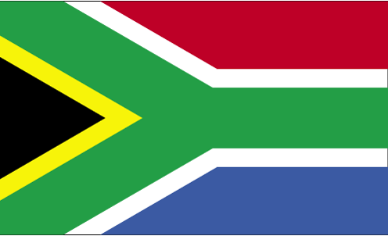  
South   
Africa

2 x 9

6 x 9

9 x 6

10 x 6

10 x 6

12 x 6

12 x 8

7 x 6

4 x 6

1 x 9

7 x 8

7 x 9

6 x 8

10 x 8

5 x 6

11 x 8

1 x 8

9 x 9

8 x 8

2 x 8

4 x 8

3 x 9

9 x 8

8 x 9

2 x 6

5 x 8

6 x 6

3 x 8

5 x 9

12 x 9

11 x 9

4 x 9

3 x 6

1 x 6

11 x 6

8 x 6

11 x 9

9 x 9

7 x 9

10 x 9

8 x 6

4 x 8

1 x 9

5 x 8

5 x 6

12 x 6

2 x 8

1 x 6

4 x 9

10 x 9

11 x 8

9 x 8

6 x 6

12 x 8



10 x 8

7 x 8

12 x 9

South Africa

8 x 8

7 x 6

1 x 8

5 x 9

2 x 6

2 x 9

11 x 6

3 x 9

9 x 6

3 x 8

4 x 6

6 x 8

8 x 9

6 x 9

3 x 6